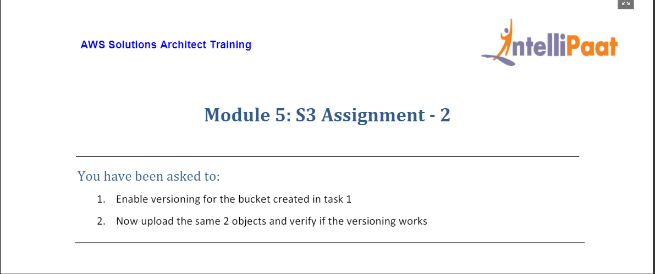

* Enabled versioning for the bucket (**mod5assignment1**) created in previous assignment.

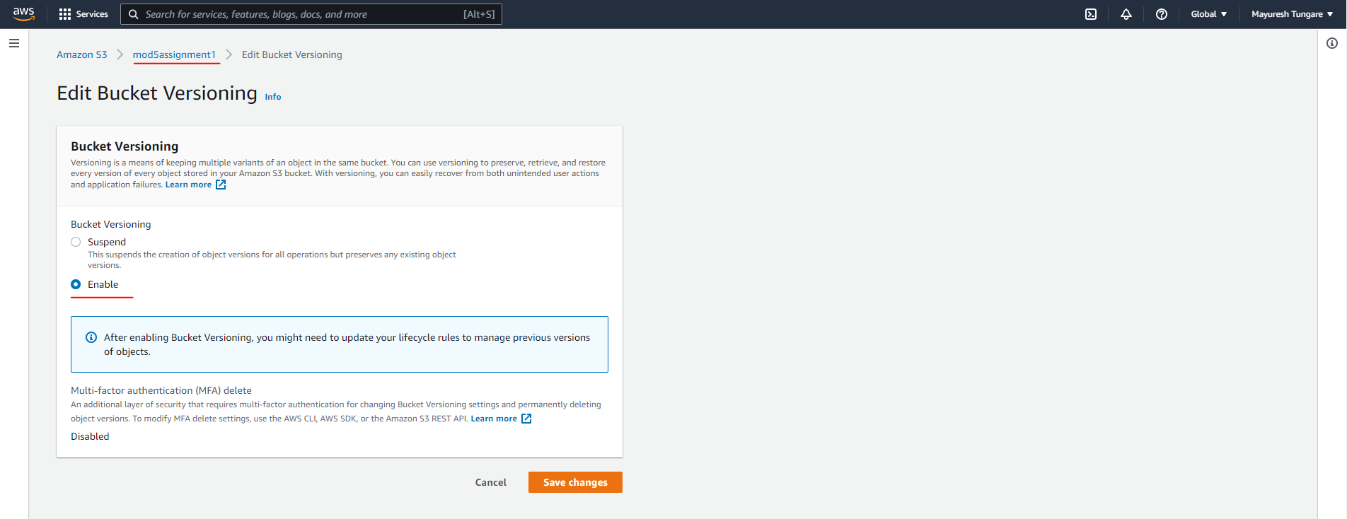

* Uploaded same objects (**Object1** and **Object2**) from previous assignment after versioning was enabled.

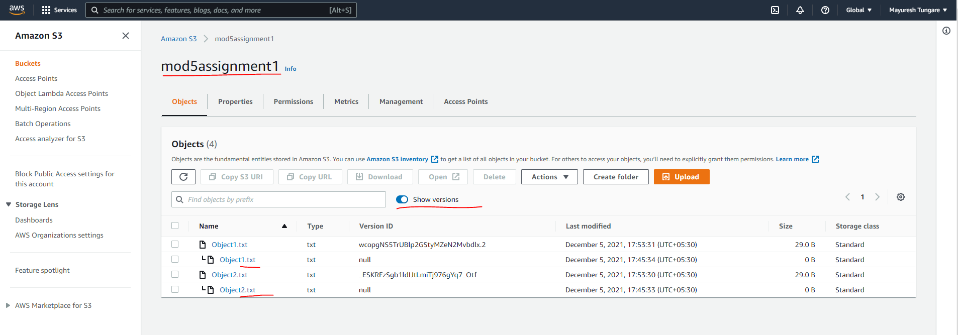

* We can now observe that versioning works and previous versions can be seen by enabling the ‘Show versions’ switch (toggle). The assignment is now complete.